CLEANLINESS WEEK 2019
(Commemoration of Mahatma Gandhi’s 150th Birth Anniversary)

In pursuance of the letter no. F.20016/1/2018-DTE(HTE), dated 7th October, 2019 from the Directorate of Higher & Technical Education, Govt. of Mizoram, the Eco-Club, Govt. Zirtiri Residential Science organised cleanliness drive on 9th October, 2019 at the college campus, Ramthar Veng, Aizawl. It was a part of observance of Cleanliness Week starting from 2nd October to 9th October, 2019 to commemorate the 150th Birth Anniversary of Mahatma Gandhi. The main purpose of this programme was to create awareness among students regarding cleanliness and its benefits.
The function started at 3:30 p.m. with a brief speech by Mr C. Lalngaihawma, Secretary of the Club on the on-going steps taken towards cleanliness all across the country and made the students aware that a clean India would be the best tribute India could pay to Mahatma Gandhi. Students and teachers dispersed to pick all types of waste lying scattered in the campus, and certain amount of waste materials was collected for proper disposal. Around 70 students and 7 teachers of the Club actively participated in this drive.

Report prepared by
C. Lalngaihawma
Secretary
Eco-Club GZRSC

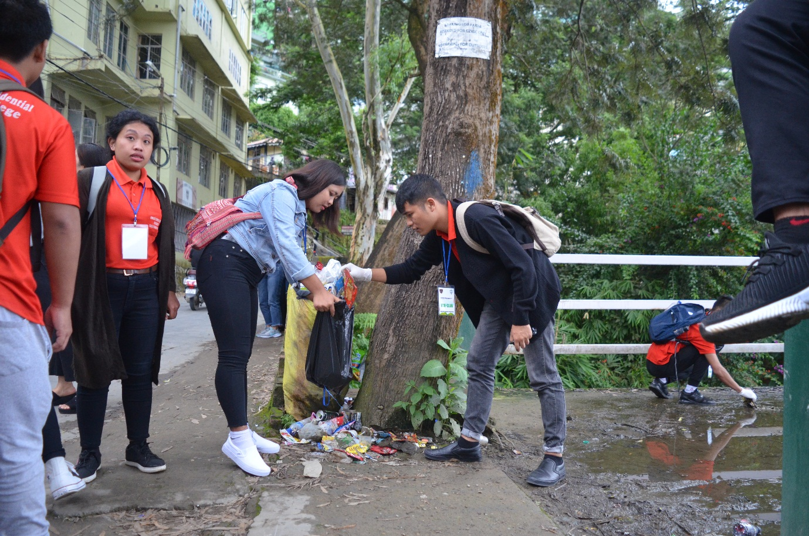
Pic 1

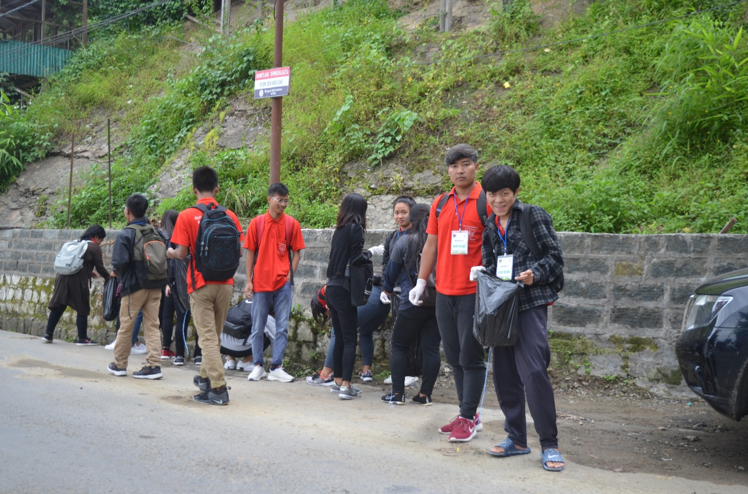
Pic 2

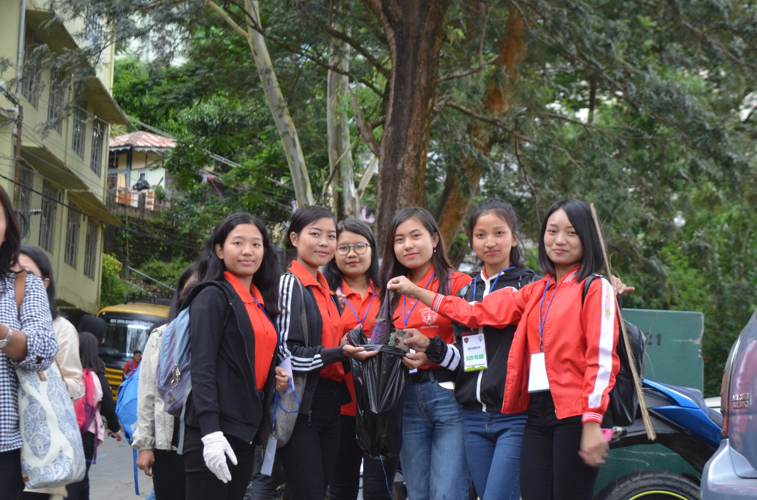
Pic 3

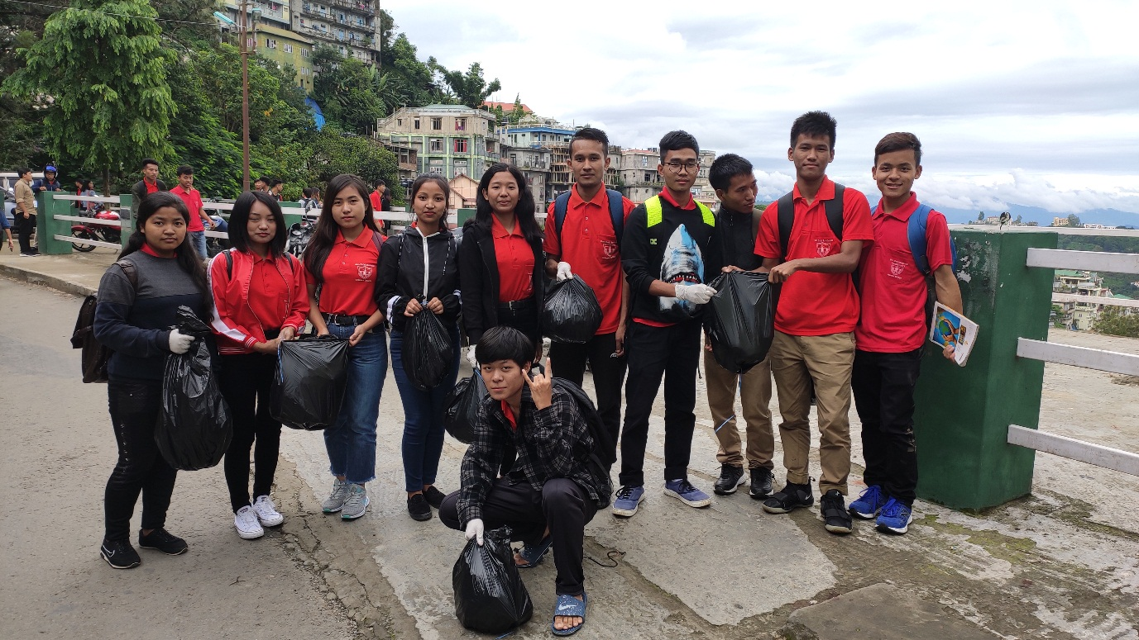
Pic 4

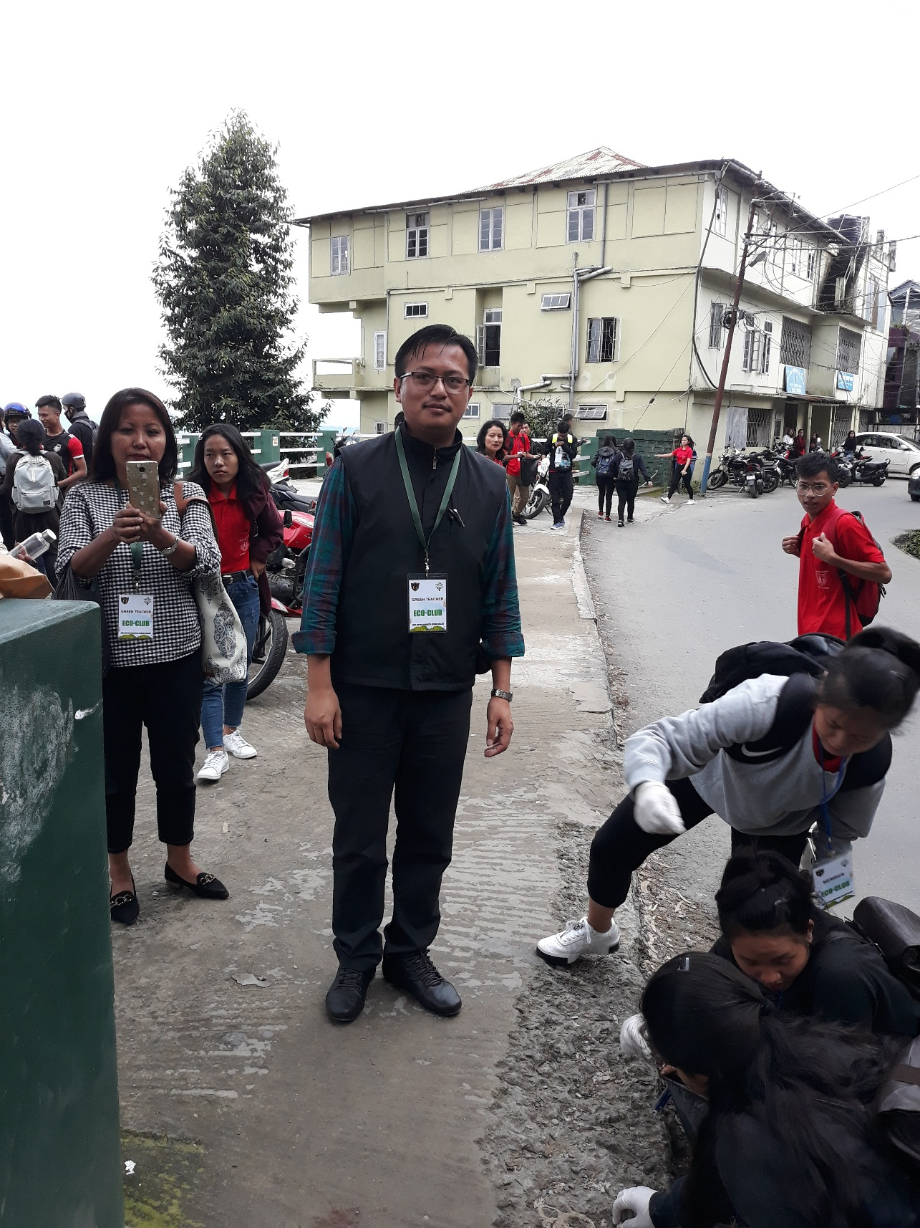
Pic 5

