SINGLE-USE PLASTICS FREE DRIVE 2019

In pursuance of the letter no. H.88088/Poltn./99/19-MPCB (dt. 12th July, 2019) from Mizoram State Pollution Control Board, the Eco-Club, Govt. Zirtiri Residential Science organised “Single-Use Plastics Free Drive” on 30th July, 2019 at the college campus, Ramthar Veng, Aizawl. The function started at 1:00 p.m. with brief speeches by Mrs Lalrosangpuii, Assistant Professor and Mr Lal\anpuia, Associate Professor on the menace of single-use plastics all across the globe and then urged the audience to participate in the on-going measures taken to reduce the use of plastics.
Students and teachers dispersed to pick all waste plastics lying in the campus, and certain amount of waste materials was collected for proper disposal. The function ended with an official photo session. Around 120 students and 10 teachers (members of Eco-Club) actively participated in this drive.

Report prepared by
C. Lalngaihawma
Secretary
Eco-Club GZRSC

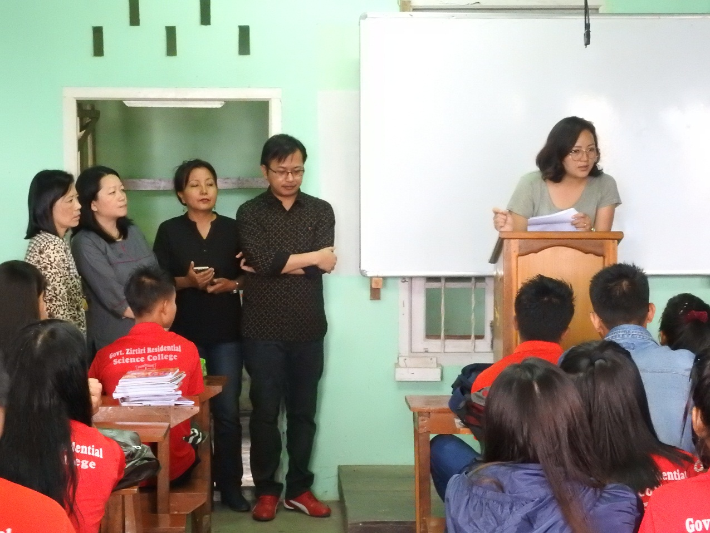
Pic 1: Mrs Lalrosangpuii, Assistant Professor delivering a speech

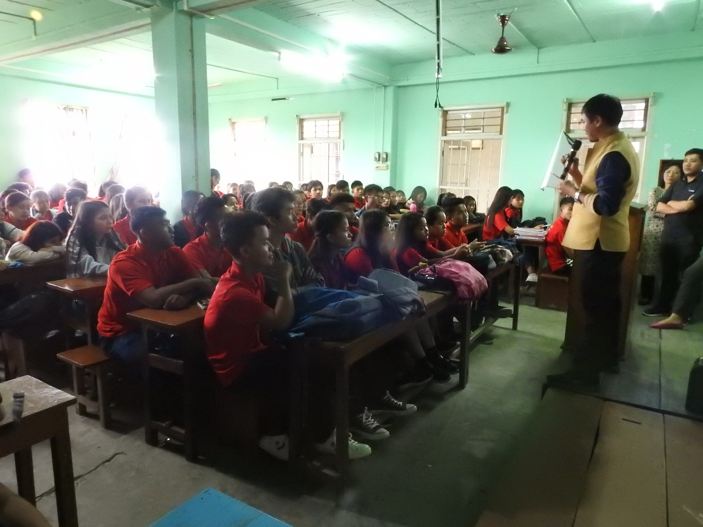
Pic 2: Mr Lal\anpuia, Associate Professor delivering a speech
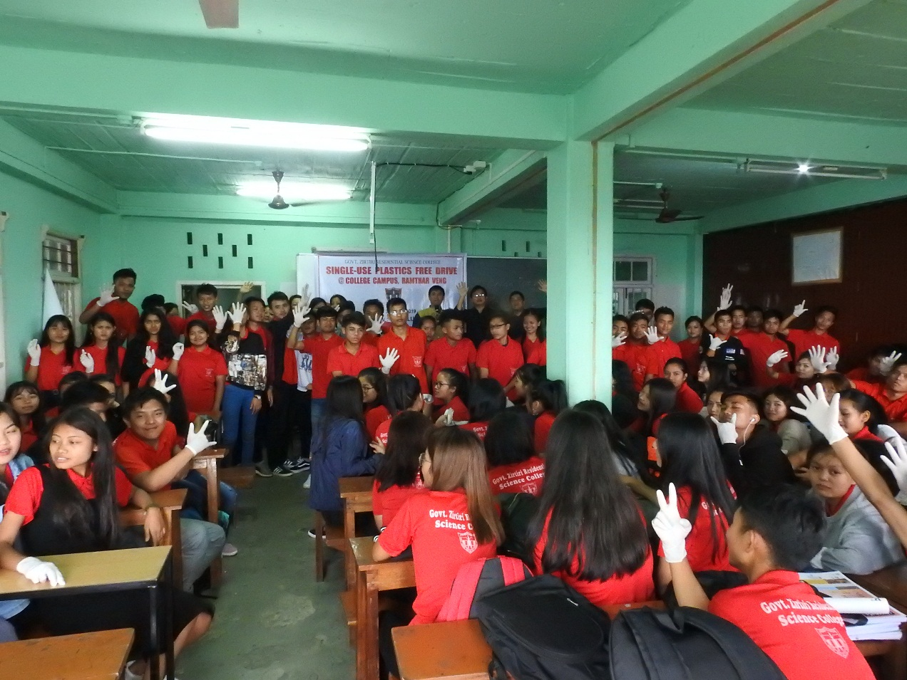
Pic 3

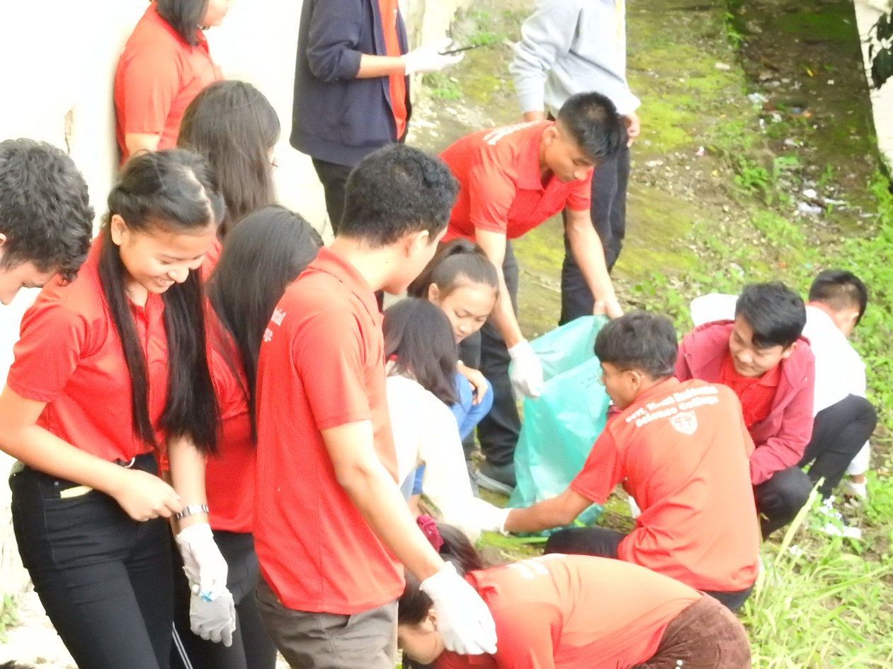
Pic 4
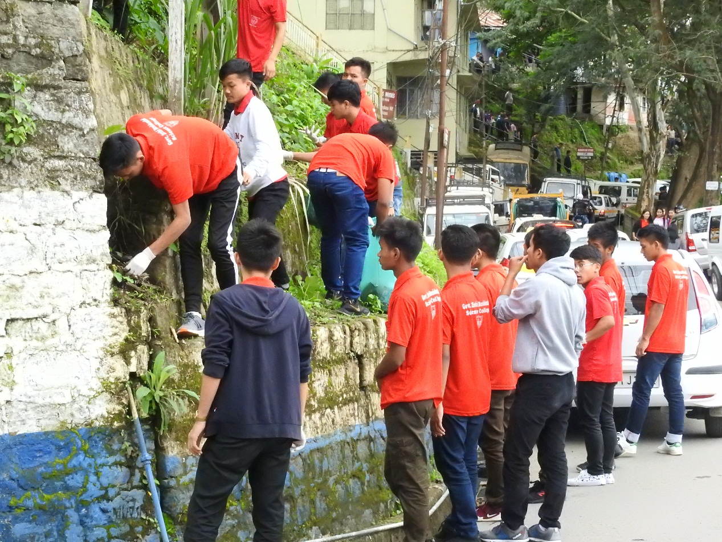
Pic 5

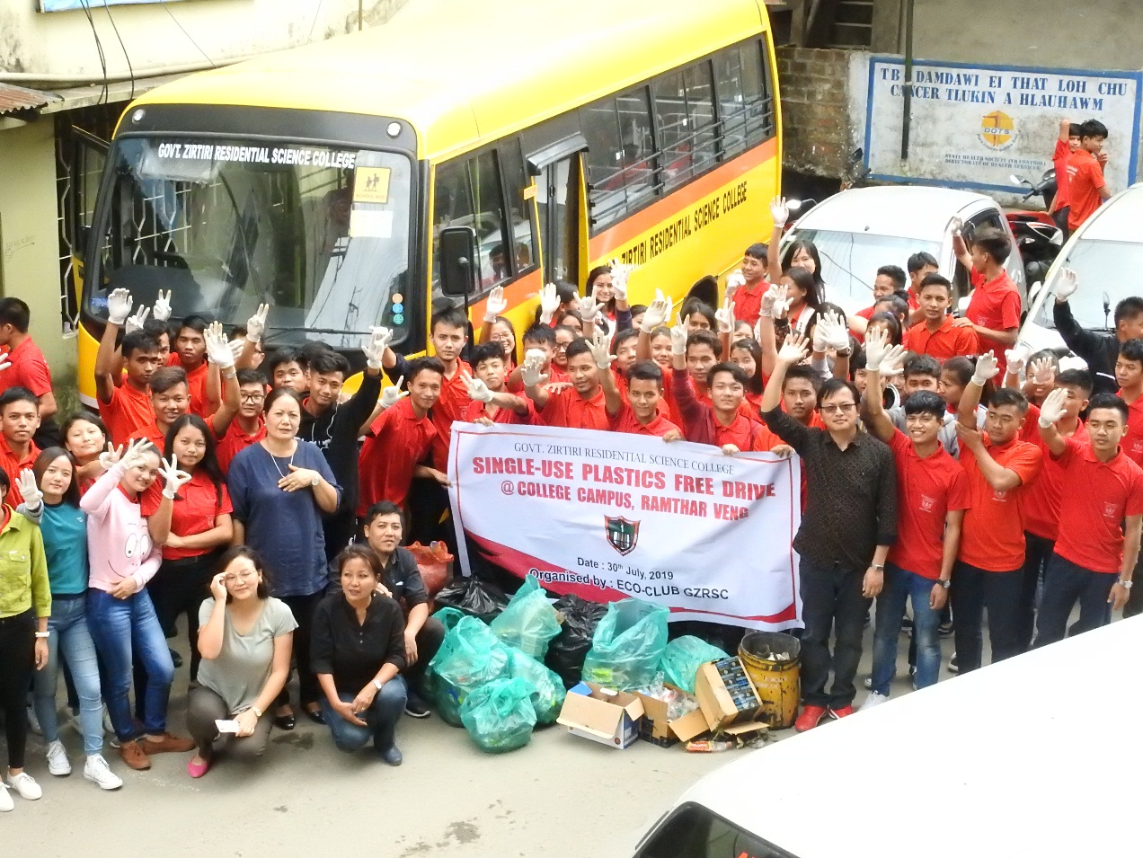
Pic 6
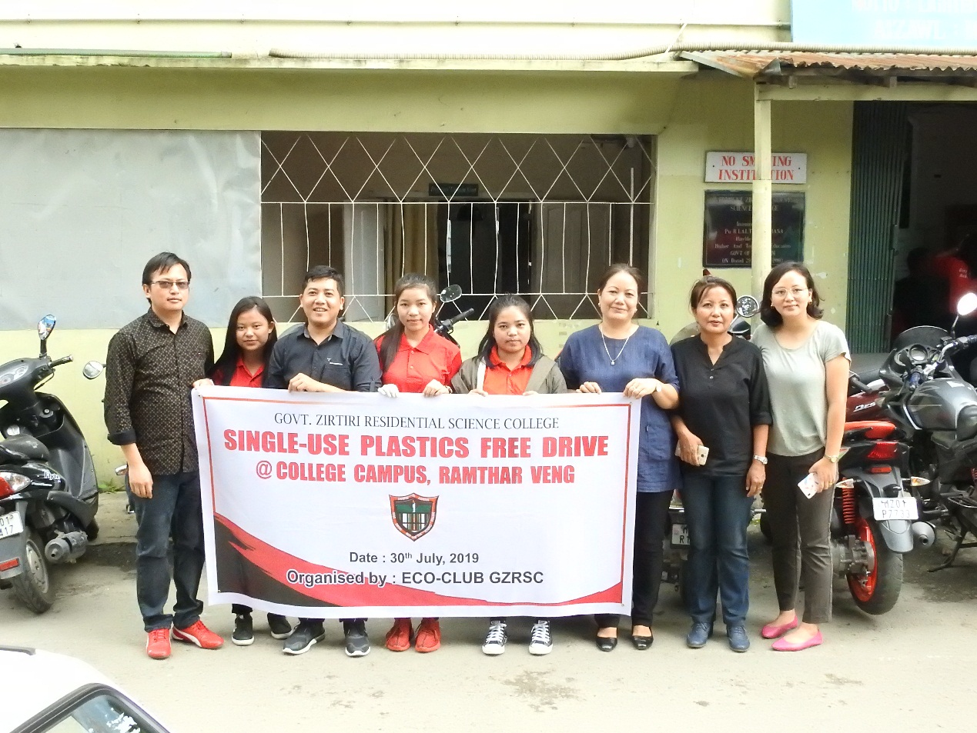
Pic 7

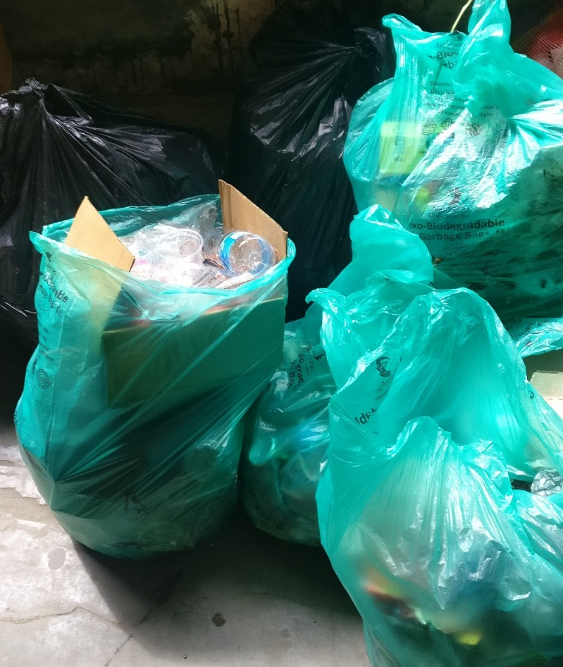
Pic 8

