AWARENESS CAMPAIGN CUM ECO-CLUB MEET 2019

The Eco-Club Govt. Zirtiri Residential Science College organised “Awareness Campaign cum Eco-Club Meet” on 1st October, 2019 at the College Auditorium.
The function commenced at 2:30 pm and was chaired by Mr C. Lalngaihawma, Secretary, Eco-Club GZRSC. The chairman introduced the Club members and then briefly highlighted various activities of the Club in the previous and the current sessions. After that Mrs Lalrosangpuii, Assistant Professor delivered a speech on “Environmental Stewardship”.
Dr C. Zoramthara, Assistant Professor conducted an election for the office bearers of the Eco-Club members of GZRSC for 2019 – 2020 session. Vanlalthanmawia (V semester, Zoology) was elected for President, Dodie Zoliansanga (V semester, Botany) for Vice President and M. Lalrinsangi (V semester, Zoology) for General Secretary. The elected office bearers have been entrusted to appoint seven (7) members to assist them.
The function came to an end with a vote of thanks from the Chairman followed by an official photo session. The event was attended by 68 students along with 7 teachers of the Club.

Report prepared by
C. Lalngaihawma
Secretary
Eco-Club GZRSC

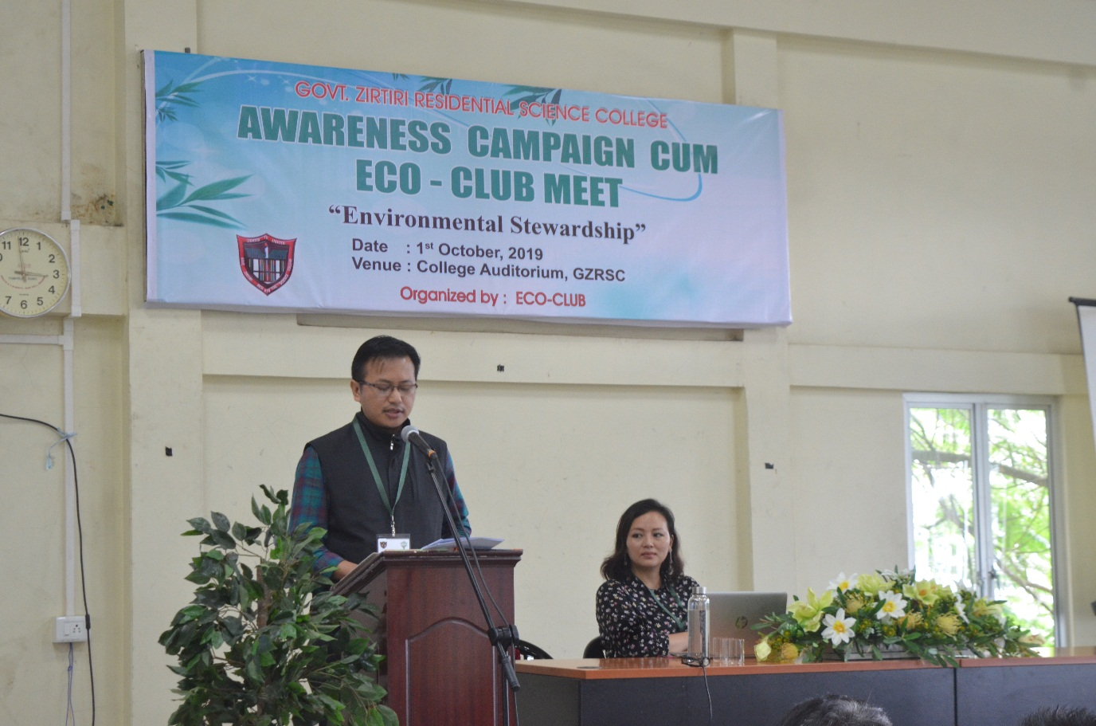
Pic 1: Mr C. Lalngaihawma, chairman of the programme giving a report

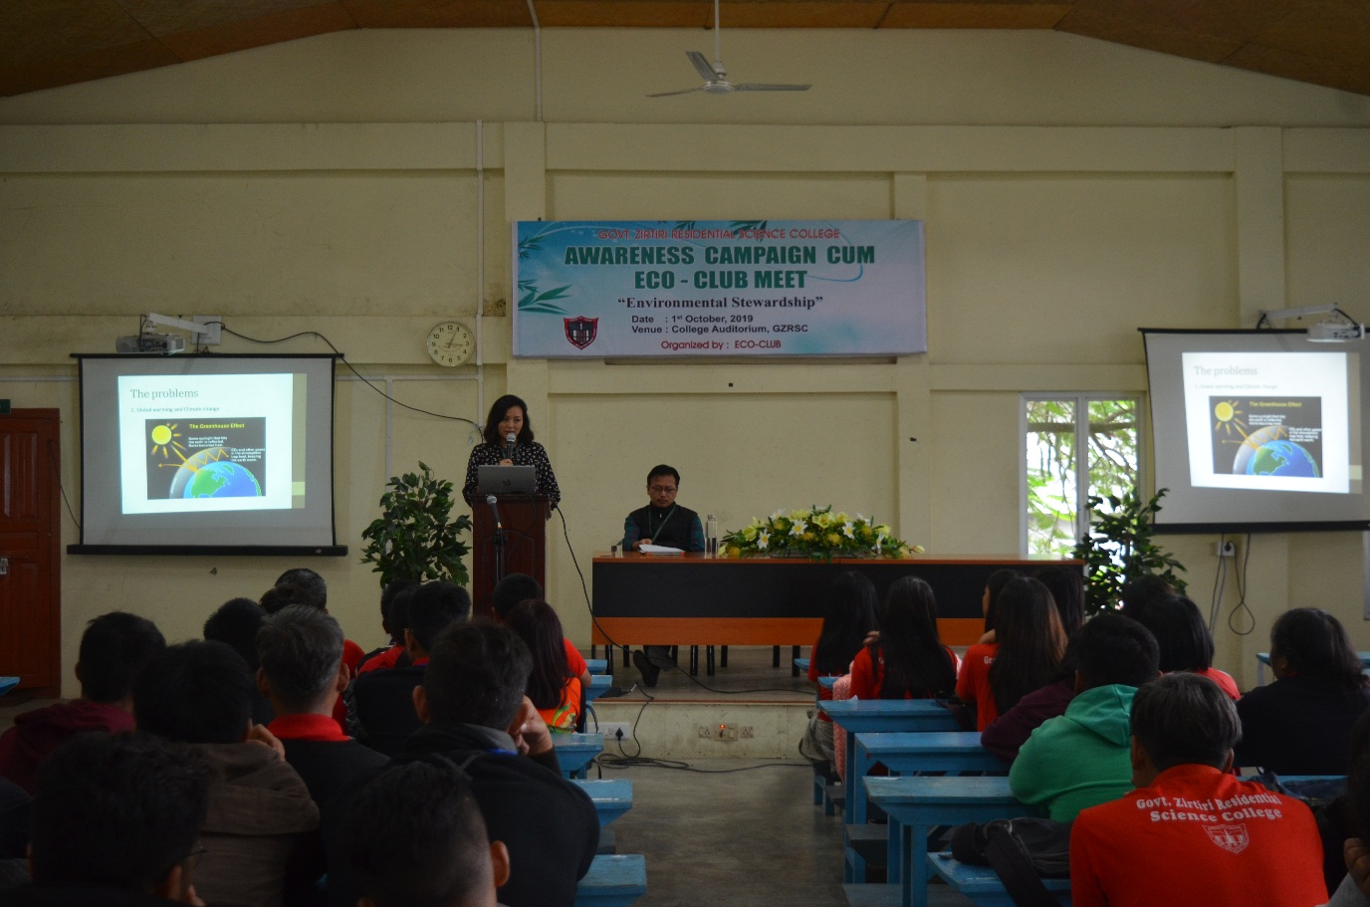
Pic 2: Mrs Lalrosangpuii, Assistant Professor delivering a speech on “Environmental Stewardship”
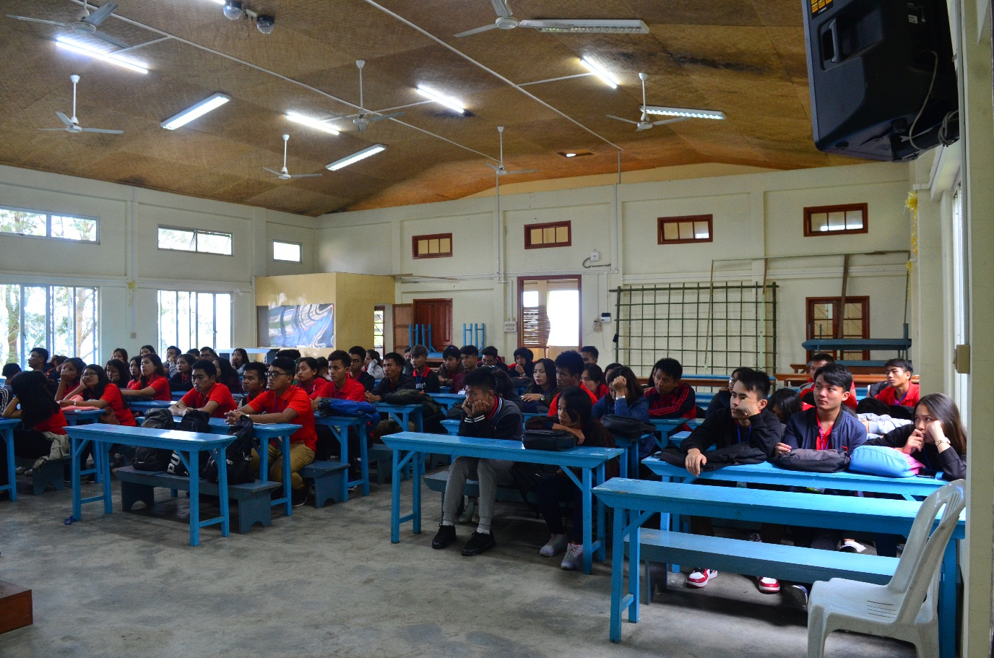
Pic 3: Members of Eco-Club GZRSC

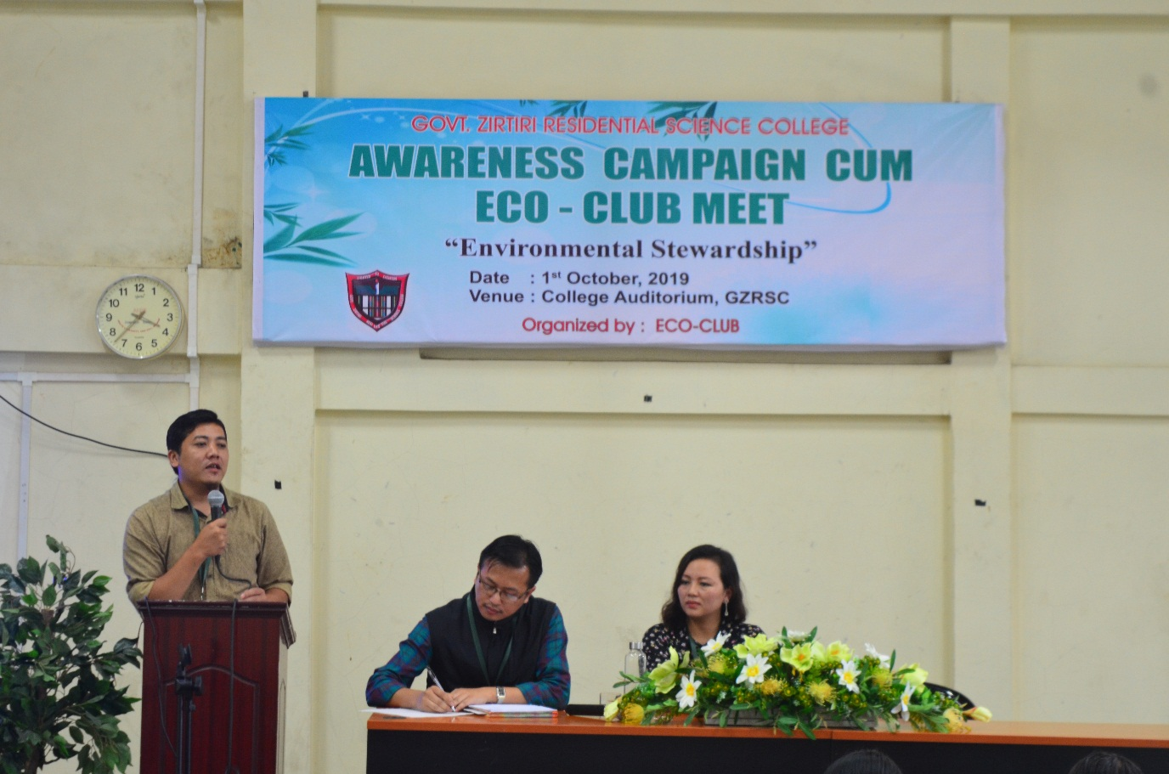
Pic 4: Dr C. Zoramthara, Assistant Professor conducting an election

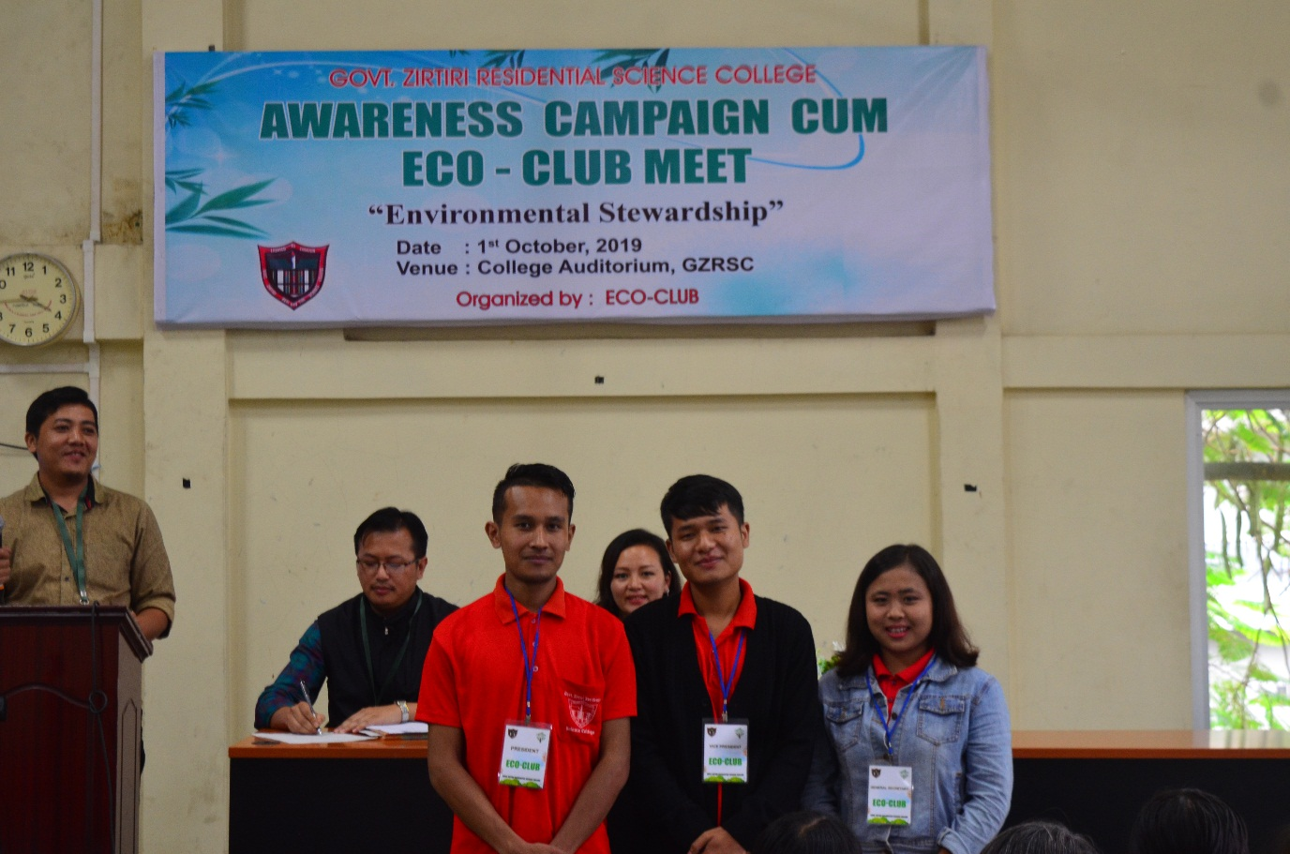
Pic 5: Newly elected office bearers for 2019 – 2020

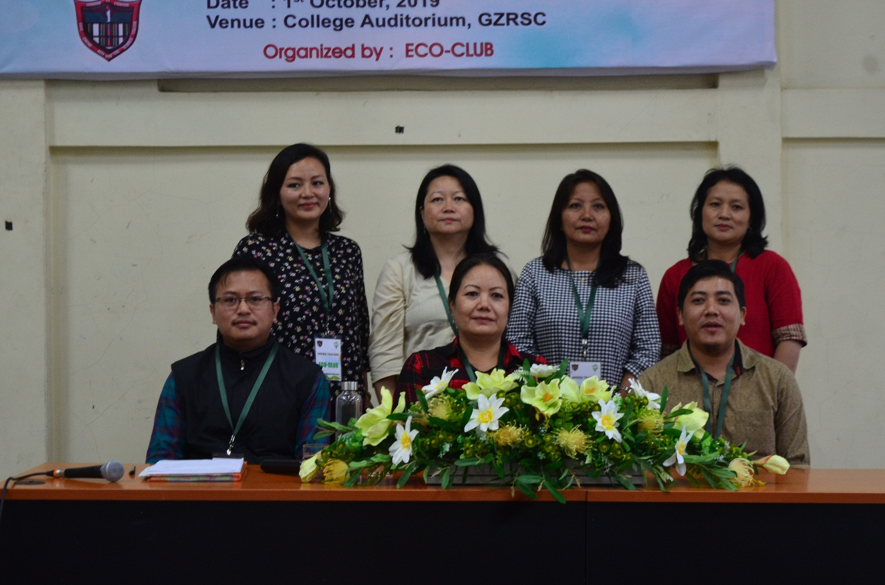
Pic 6: Green Teachers

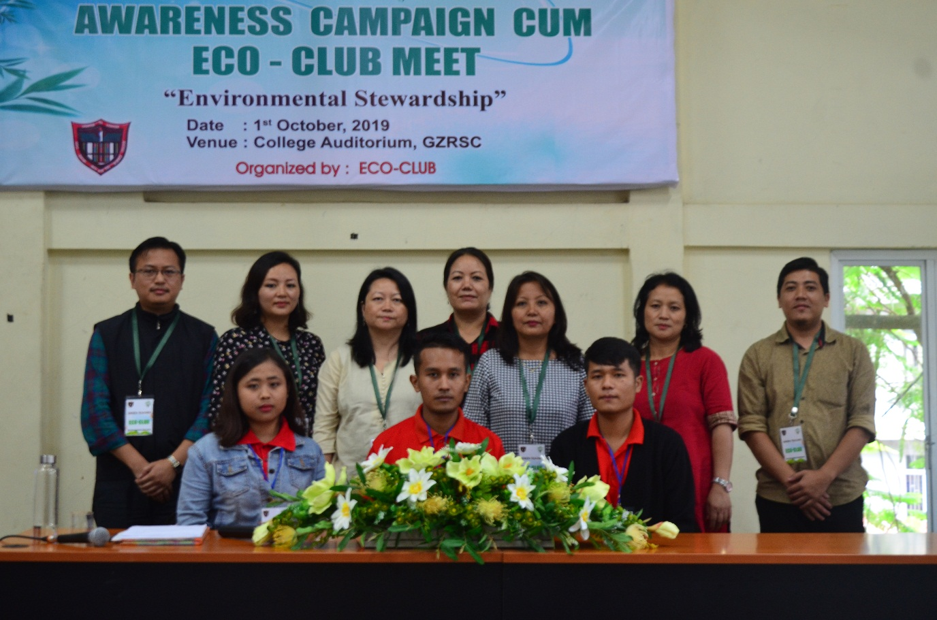
Pic 7: Newly elected office bearers with Green Teachers

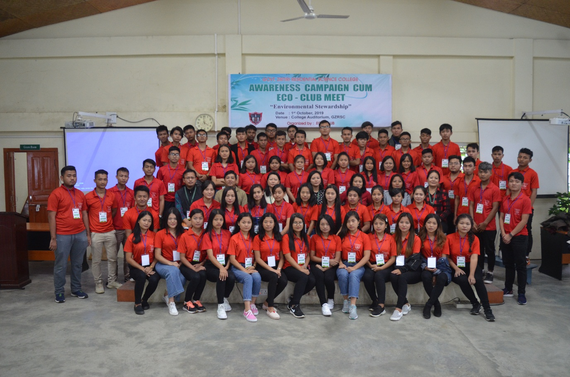
Pic 8: Members of Eco-Club GZRSC with Green Teachers

